IBM ASSIGNMENT

CREATE CIRCUIT WITH PIEZO ALARM,PIR SENSOR,TEMPERATURE SENSOR:

CIRCUIT DIAGRAM:

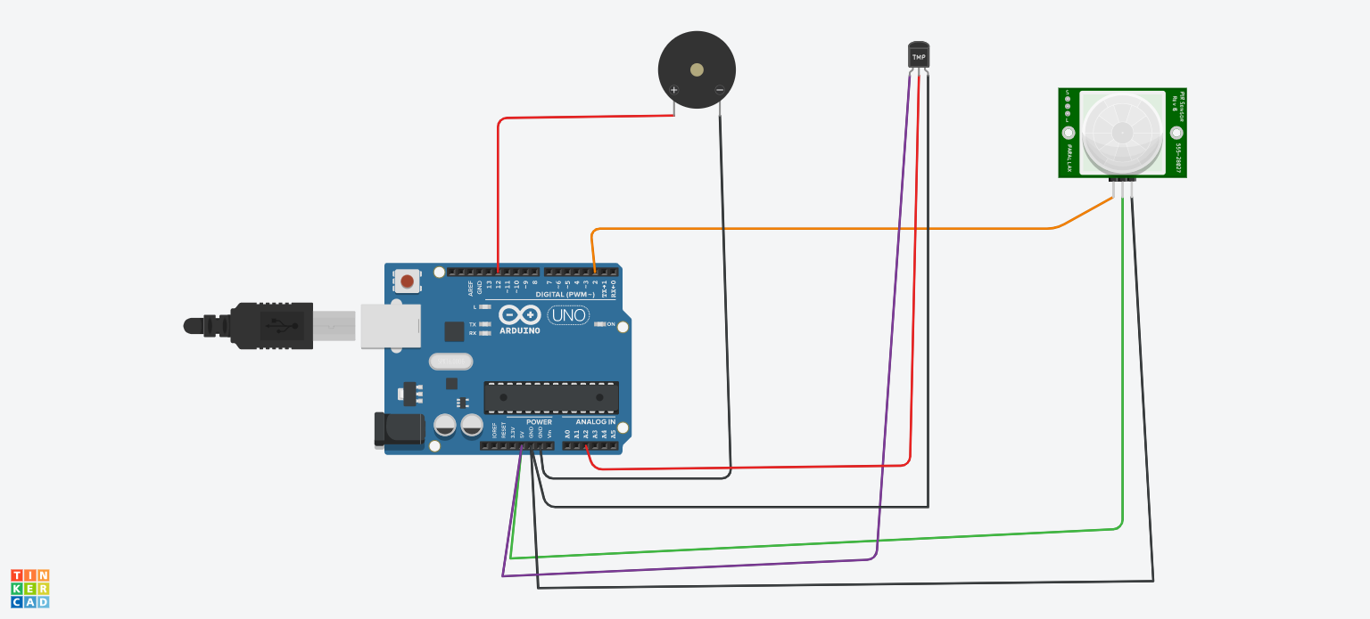

SCHEMATIC DIAGRAM:

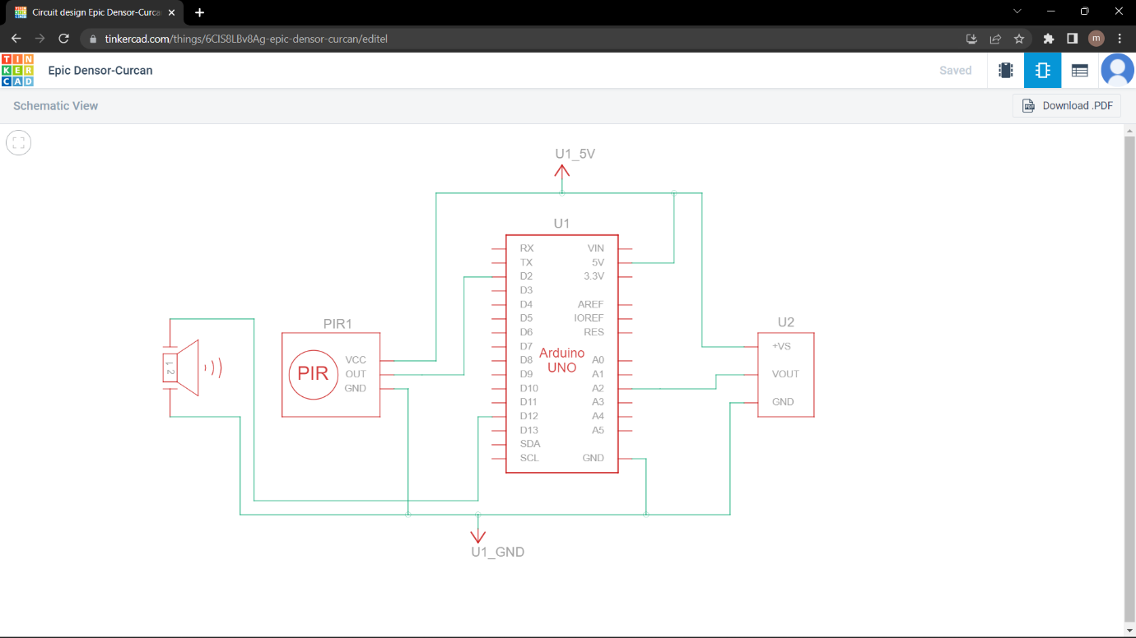

Source code:

// C++ code

//

void setup()

{

Serial.begin(9600);

pinMode(2, INPUT);

pinMode(12, OUTPUT);

}

void loop()

{

int motion=digitalRead(2);

if(motion==1)

{

Serial.println("Motion is Detected !");

tone(12,10);

delay(1000);

noTone(12);

delay(3000);

}

else

{

Serial.println("No Motion!!!");

delay(1000);

}

double data=analogRead(A2);

double n=data/1024;

double voltage=n\*5;

double offsetvol=voltage-0.5;

double temp=offsetvol\*100;

if(temp>60)

{

Serial.println("Temperature higher than 60 degrees !!");

Serial.println(temp);

tone(12,10);

delay(1000);

noTone(12);

delay(3000);

}

else

{

Serial.println("Temperature lesser than 60 degrees !!");

Serial.println(temp);

delay(1000);

}

}

Temp sensor:

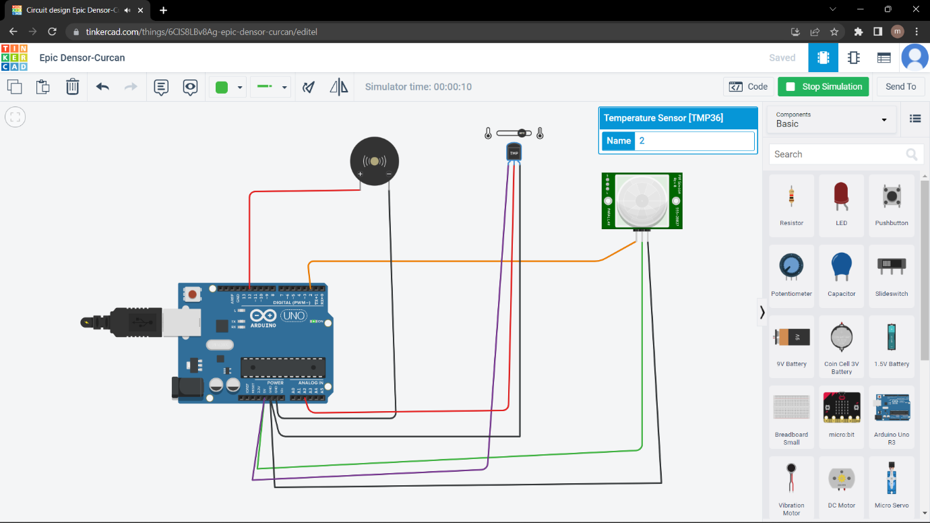

Pir sensor:

